Lab program 2

Pooja K

1BM19CS111

Consider the following database for a banking enterprise.

BRANCH (branch-name: String, branch-city: String, assets: real)

ACCOUNTS (accno: int, branch-name: String, balance: real)

DEPOSITOR (customer-name: String, customer-street: String,

customer-city: String)

LOAN (loan-number: int, branch-name: String, amount: real)

BORROWER (customer-name: String, loan-number: int)

i) Create the above tables by properly specifying the primary keys and the foreign keys.

create table branch(branch_name varchar(30),branch_city varchar(20),assets int,primary key(branch_name));

create table account(accno int,branch_name varchar(20),balance int,primary key(accno));

create table customer(customer_name varchar(20),customer_street varchar(20),customer_city varchar(20),primary key(customer_name));

create table depositor(customer_name varchar(20),accno int,primary key(customer_name,accno),foreign key(customer_name) references customer(customer_name),foreign key(accno) references account(accno) on delete cascade);

create table loan(loan_number int,branch_name varchar(20),amount int,primary key(loan_number),foreign key(branch_name) references branch(branch_name));

create table borrower(customer_name varchar(20),loan_number int,primary key(customer_name,loan_number),foreign key(customer_name) references customer(customer_name),foreign key(loan_number) references loan(loan_number));

ii) Enter at least five tuples for each relation.

insert into branch(branch_name,branch_city,assets)

VALUES

('ICICI_Madiwala','Bangalore', 100000.00),

('ICICI_BTMlayout','Bangalore', 200000.00),

('ICICI_Jayanagar','Bangalore', 250000.00),

('ICICI_Deoli','delhi', 400000.00),

('ICICI_shergarh','delhi', 250000.00);

insert into account(accno,branch_name,balance)

VALUES

(1,'ICICI_Madiwala', 1000.50),

(2,'ICICI_BTMlayout', 2345.0),

(3,'ICICI_Jayanagar', 4009.25),

(4,'ICICI_Deoli', 5670.00),

(5,'ICICI_shergarh',10000.50);

INSERT INTO customer(customer_name,customer_street,customer_city)

VALUES

('Anand','Bull temple road','Bangalore'),

('Charan','Banerghatta road','Bangalore'),

('Jagan','National college road','Bangalore'),

('Abdul','Akoli road','Delhi'),

('Vineeth','Shahjahan road','Delhi');

INSERT INTO depositor(customer_name,accno)

VALUES

('Anand',1),

('Charan',2),

('Jagan',3),

('Abdul',4),

('Vineeth',5);

INSERT INTO loan(loan_number,branch_name,amount)

VALUES

(1,'ICICI_BTMlayout',1500),

(2,'ICICI_Deoli',4250),

(3,'ICICI_Jayanagar',5000),

(4,'ICICI_Madiwala',2000),

(5,'ICICI_shergarh',2500);

iii) Find all the customers who have at least two accounts at the Main branch.

select d.customer_name from depositor d,account a where a.accno=d.accno and a.branch_name='ICICI_Deoli' group by d.customer_name having count(*)>=2;

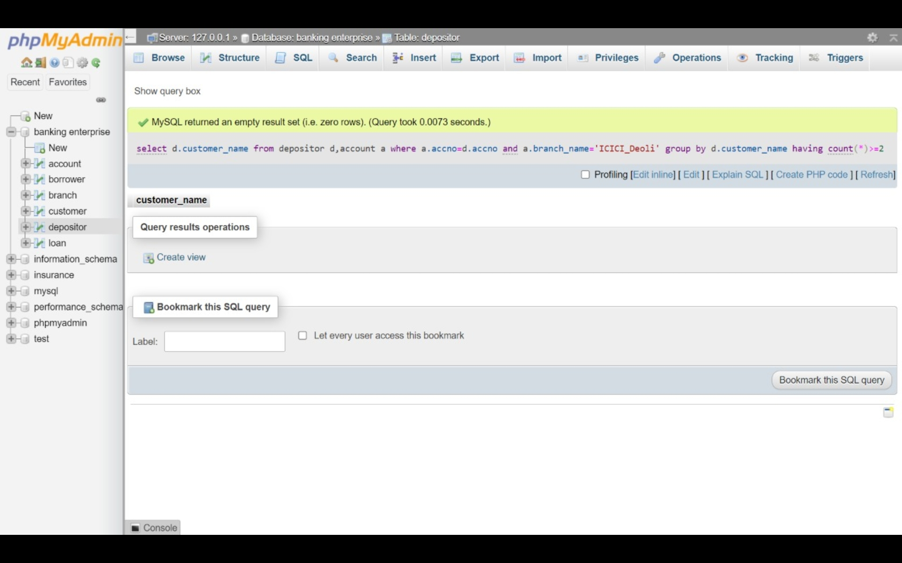

v) Demonstrate how you delete all account tuples at every branch located in a specific city.

delete from account where accno in (select a.accno from account a,branch b where a.branch_name=b.branch_name and b.branch_city='Bangalore');